SmartSpray — Frontend Specification Document
Product: SmartSpray AI Precision Sprayer
Platform: Flutter / Dart
Primary device: Android phone
Backend: FastAPI running on local laptop
AI: Python + YOLO/OpenCV on laptop
Hardware: ESP32 + servo + pump
Connectivity: Local Wi-Fi + HTTP/WebSocket
Design goal: Professional agricultural-tech product, not an “Arduino project” UI.

1. Frontend Product Definition
The SmartSpray app is the farmer/operator control center for the physical AI sprayer.
It should allow the user to:
- Connect to the sprayer.
- See device health.
- Start AI scanning.
- See disease/severity results.
- Use AUTO mode.
- Use ASSISTED mode.
- Use MANUAL mode.
- Stop spraying immediately.
- Review spraying history.
- View basic statistics.
- Configure permitted settings.

Core interaction
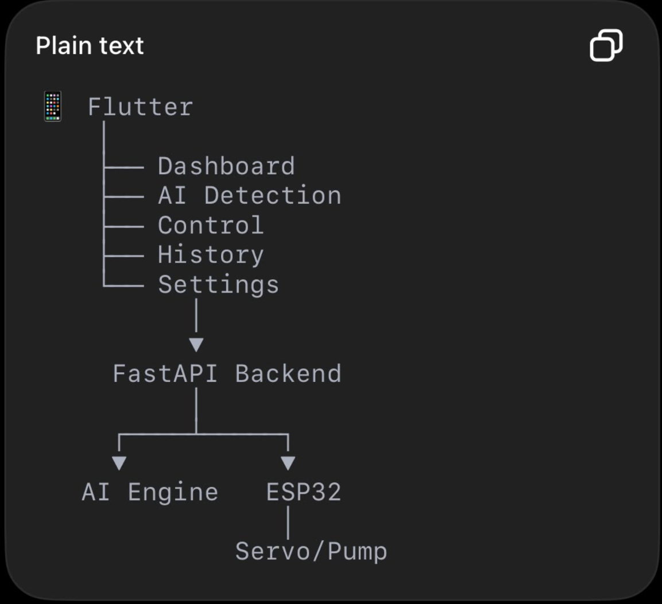
The app does not directly communicate with the pump.

2. UX Principles

P1 — Action first
The farmer should never have to navigate through multiple screens to stop spraying.
STOP must always be accessible during an active spray.

P2 — AI should be understandable
Don’t show:
segmentation_confidence = 0.93472
Show:
Disease detected
Confidence: 93%

P3 — Don’t hide uncertainty
If AI is uncertain:
AI is uncertain
Please review before spraying.
Not:
Disease detected

P4 — Physical-world state is more important than app state
If the app says:
Pump OFF
but the ESP32 says:
Pump ON
the UI must show an error state, not blindly display the app’s requested state.

P5 — One-handed operation
The operator may be holding the sprayer.
Important controls should be large and reachable.

3. Design Direction

Visual style
Modern agricultural technology
Think:
- Clean
- Professional
- Natural
- High contrast
- Minimal
- Functional
- Slightly industrial
Avoid:
- Excessive gradients
- Neon “AI” aesthetics
- Futuristic dashboards
- Too many tiny charts
- Excessive animations

4. Color System

Primary

Smart Green
Primary: #2E7D32
Used for:
- Primary buttons
- Active states
- Brand elements
- Positive actions

Primary Dark
#1B5E20
Used for:
- Pressed state
- Headers
- Strong emphasis

Primary Light
#E8F5E9
Used for:
- Background highlights
- Healthy status
- Selected cards

5. Neutral Palette
Background: #F7F9F7
Surface: #FFFFFF
Surface Secondary:#F1F4F1

Text Primary: #172018
Text Secondary: #5F6B61
Text Disabled: #9AA39C

Border: #DDE3DE
Divider: #E7EBE7

6. Status Colors

Healthy / Success
#2E7D32

Warning
#F9A825

Moderate
#EF8F00

Severe / Error
#C62828

Info
#1565C0

Offline
#757575

7. Dark Emergency Color
Emergency controls should be visually distinct.
Emergency Red: #D32F2F
Emergency Dark: #B71C1C
Do not use red for ordinary actions.
Red should mean:
Stop / danger / error

8. Typography
Use Inter.
Why:
- Highly readable
- Excellent for dashboards
- Good numerals
- Professional
- Works well on Android
- Strong hierarchy

Typography scale
Style | Size | Weight
Display | 28 px | 700
H1 | 24 px | 700
H2 | 20 px | 700
H3 | 18 px | 600
Body Large | 16 px | 400
Body | 14 px | 400
Label | 13 px | 600
Caption | 12 px | 400
Numeric KPI | 28–32 px | 700
Avoid using more than 3–4 weights.

9. Spacing System
Use an 8-point spacing system.
4 → micro
8 → small
12 → compact
16 → standard
24 → section
32 → large
40 → major section
48 → screen-level

Default screen padding
16 px

Card padding
16 px

Between major sections
24 px

10. Border Radius
Use consistent rounding.
Small controls: 8 px
Cards: 12 px
Large cards: 16 px
Bottom sheets: 24 px
Pills: 999 px
Don’t make every component extremely rounded.

11. Elevation
Keep shadows subtle.

Standard card
Elevation: 1–2

Modal
Elevation: 8+

Floating action control
Elevation: 4
The app should look clean rather than “floating everywhere.”

12. Buttons

Primary Button
Background: #2E7D32
Text: #FFFFFF
Height: 48 px
Radius: 12 px
Horizontal padding: 20 px
Example:
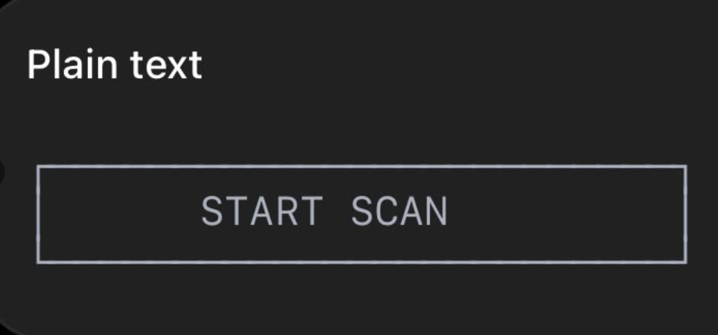

Secondary Button
Background: transparent
Border: #2E7D32
Text: #2E7D32

Destructive Button
Background: #D32F2F
Text: #FFFFFF
Use for:
STOP
Emergency Stop
Do not use for ordinary navigation.

Icon Button
Minimum touch target:
48 × 48 px
Even if the visible icon is only 24 px.

13. Emergency Stop Component
This deserves special treatment.
During active spraying:
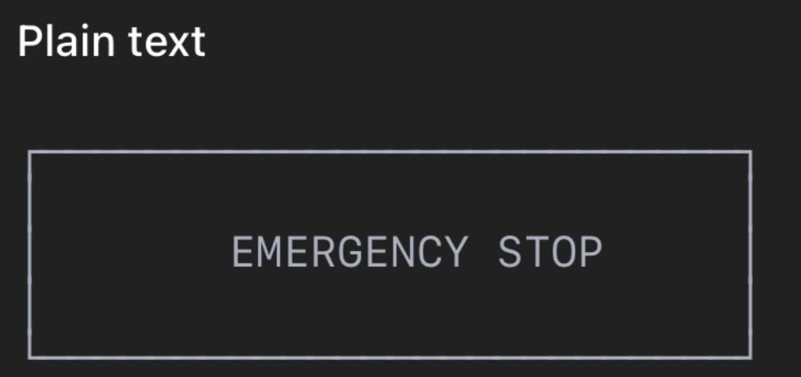Properties:
- Red
- Large
- Always visible during spraying
- Confirmation should not be required
If someone needs to stop a physical pump, forcing them through:
“Are you sure?”
is bad UX.
Pressing Emergency Stop should immediately issue the stop command.

14. Inputs

Text field
Height: 48–52 px
Radius: 10 px
Border: #DDE3DE
Focus:
Border: #2E7D32
Error:
Border: #C62828

15. Slider
Use for:
- Servo angle in manual mode
- Spray duration
- Calibration
Example:
Servo angle

20° ─────────●──────── 160°
87°
Always show the numerical value.
Never make the user guess where the slider is.

16. Cards
Cards are the main information containers.

Device status card
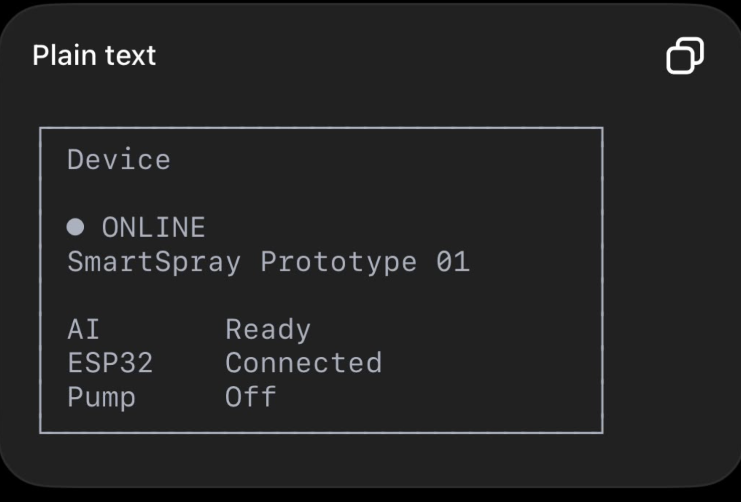
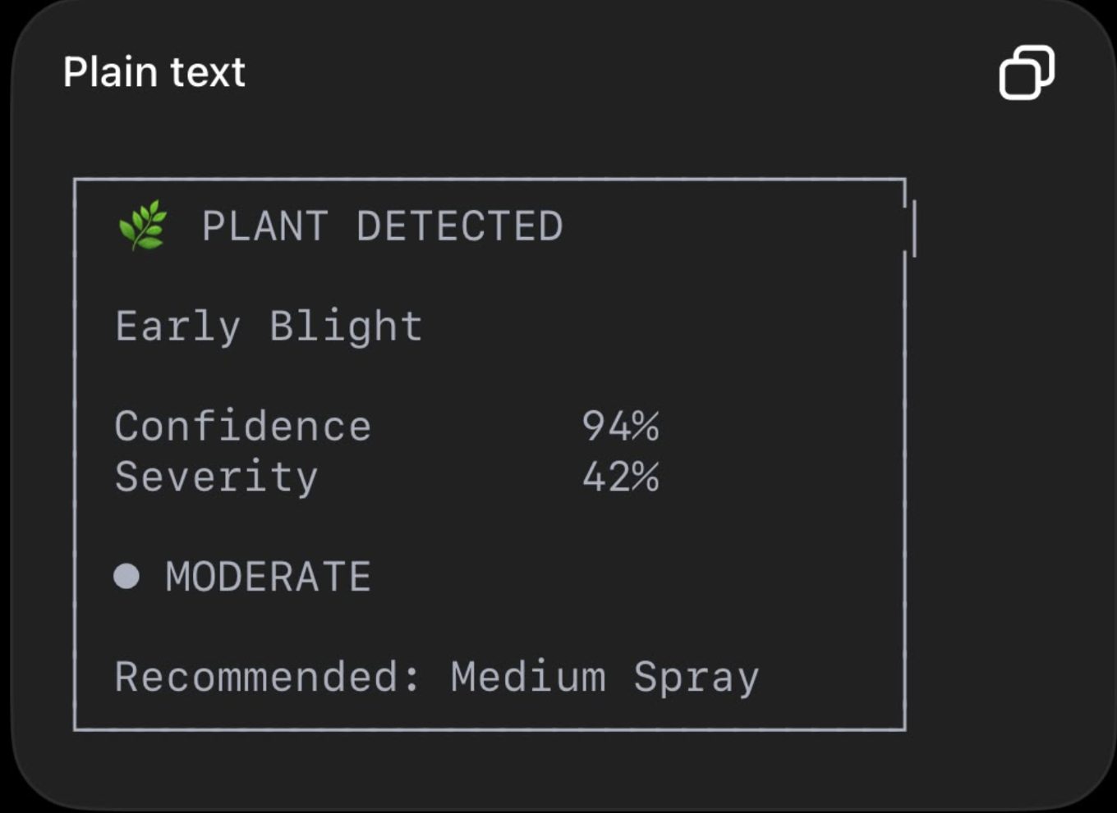
Severity should have both:
- Percentage
- Human-readable category

18. Status Indicators
Use:
● ONLINE
● READY
● SPRAYING
● OFFLINE
● ERROR
Never rely on color alone.
For example:
🟢 ONLINE
rather than just a green dot.
This improves accessibility.

19. App Navigation
Use bottom navigation with 4 primary destinations:
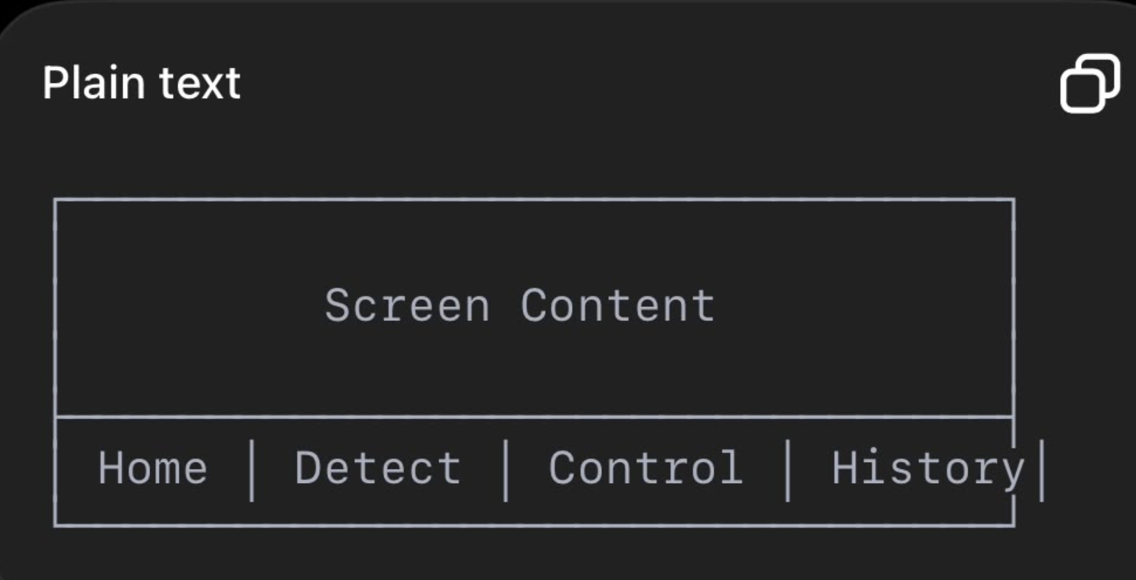
Settings can be accessed from the Home screen rather than consuming a fifth primary navigation item.

Navigation
Home
├── Device details
└── Settings

Detect
└── Detection details

Control
├── Auto
├── Assisted
└── Manual

History
└── Spray details

20. Home Screen

Layout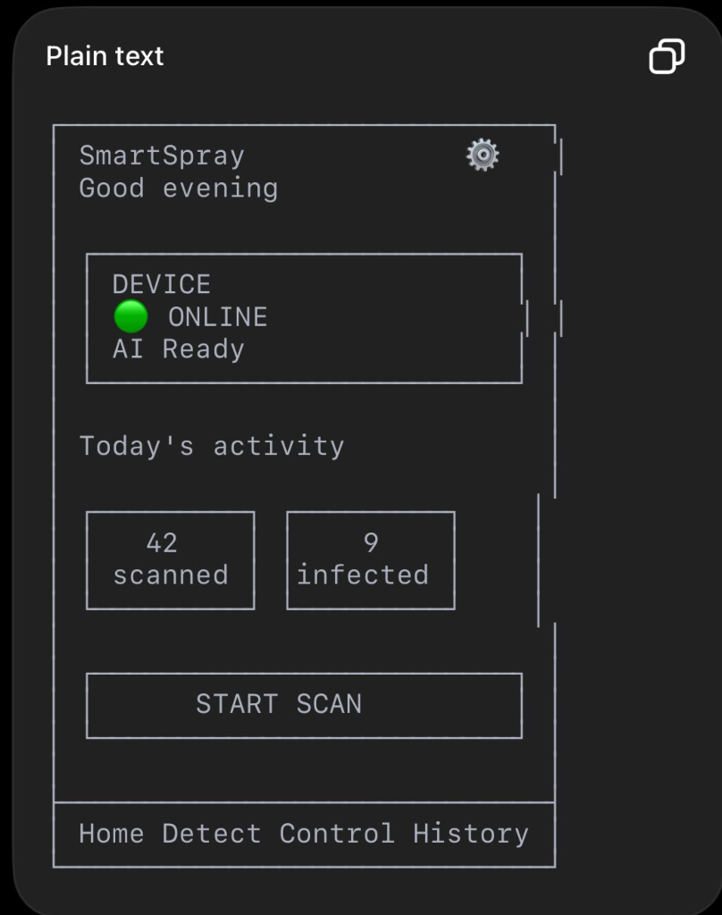

21. Detection Screen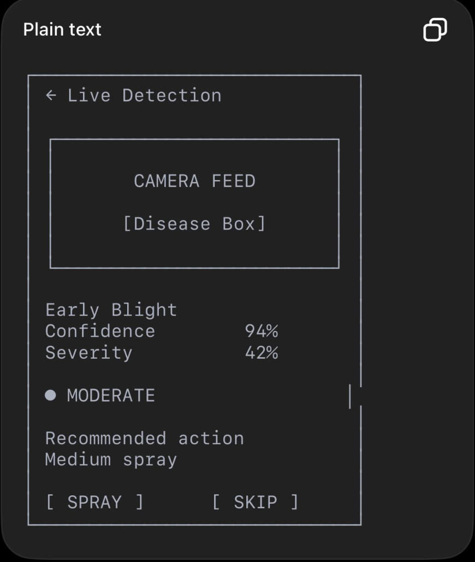
This is the most important screen for the AI story.

Important
For the first version, the camera feed can remain on the laptop.
The app can show the AI result rather than streaming the entire video to the phone.
That reduces complexity considerably.

22. Control Screen

Mode selector
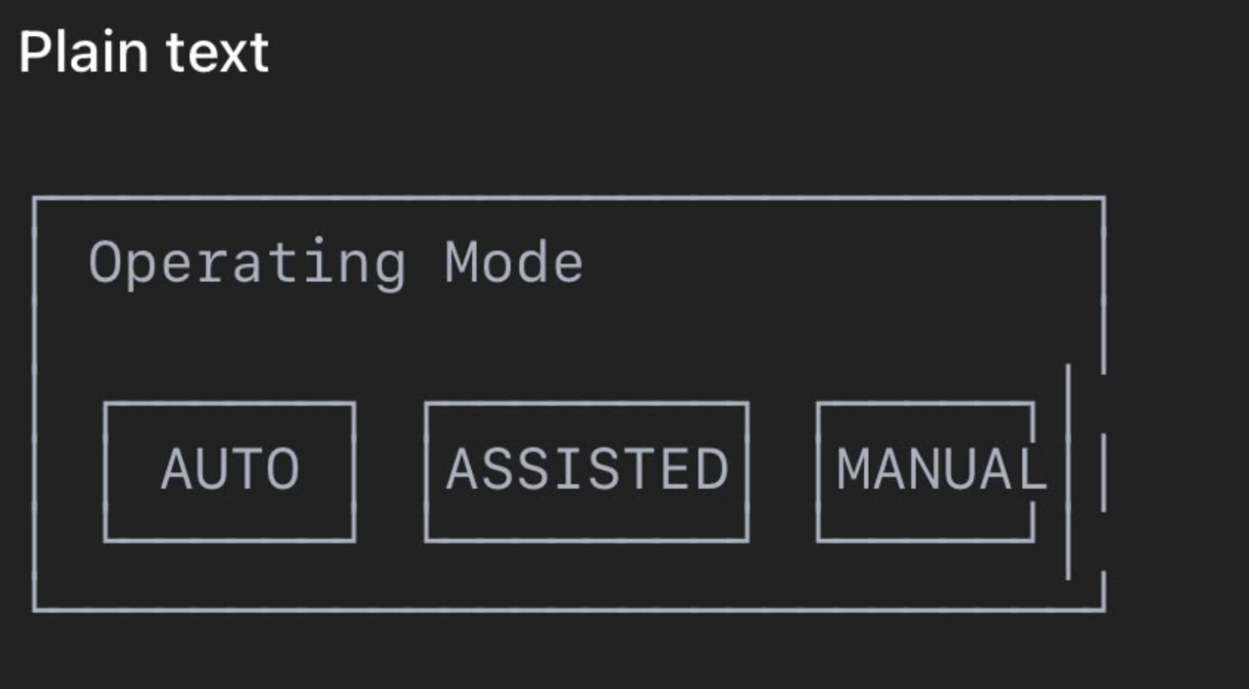

23. Auto Mode
Show:
AI CONTROL ACTIVE

Camera: READY
AI: READY
ESP32: CONNECTED

Current:
Plant #17

Disease:
Early Blight

Severity:
62%

Action:
MODERATE SPRAY
The app should not clutter the screen with manual controls while AUTO is active.

24. Assisted Mode
This is the ideal demo mode.
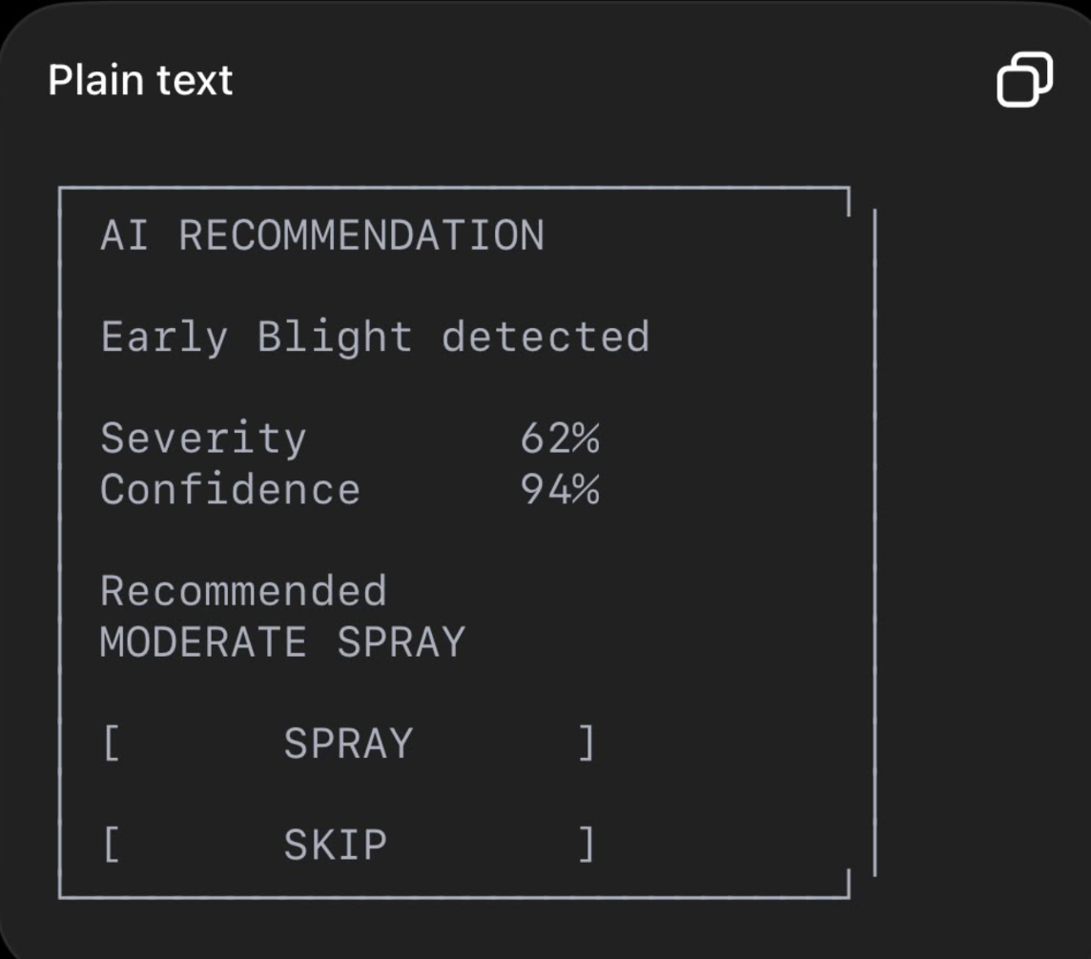

25. Manual Mode
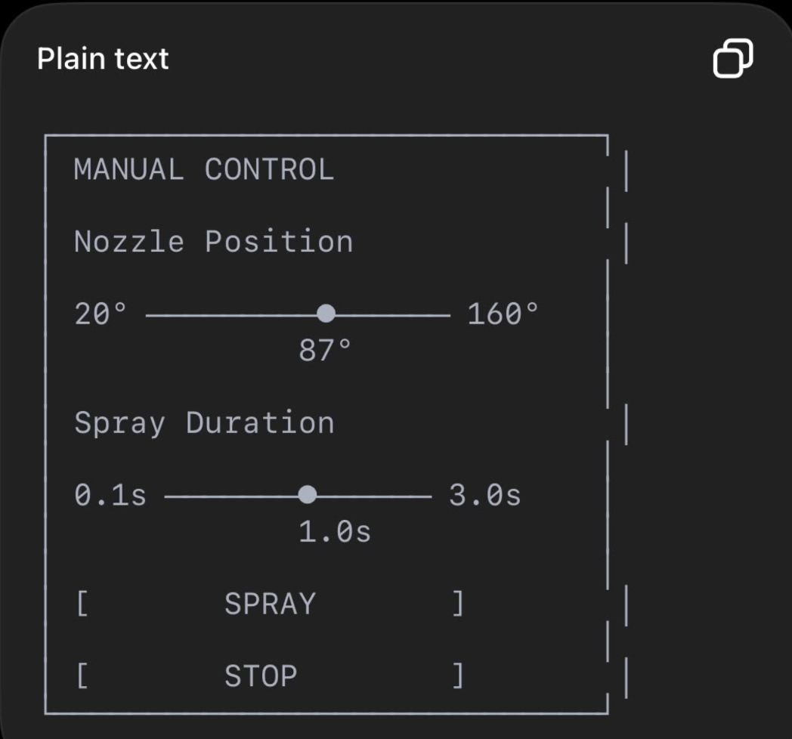

26. History Screen
Use a timeline/list rather than a huge table.
TODAY

14:32
🔴 Early Blight
Severity: 62%
Moderate spray
Completed

14:29
🟢 Healthy
No spray

14:27
🔴 Early Blight
Severity: 41%
Moderate spray
Completed
Tap an event for details.

27. Statistics
Use only a few useful metrics.
Today's Summary

42 Plants scanned

9 Infected

7 Sprays

83% Healthy
A small chart can show:
Healthy ███████████████
Infected █████
Sprayed ████
Do not build a complex analytics dashboard for V1.

28. Settings
Sections:

Device
- Device name
- Connection
- Firmware version

Spraying
- Spray calibration
- Maximum duration
- Servo limits

AI
- Confidence threshold
- Disease model
- Severity thresholds

About
- App version
- Model version
- Device version
Safety-critical settings should be Admin-only.

29. Modal Design
Use bottom sheets for short actions.
Example:
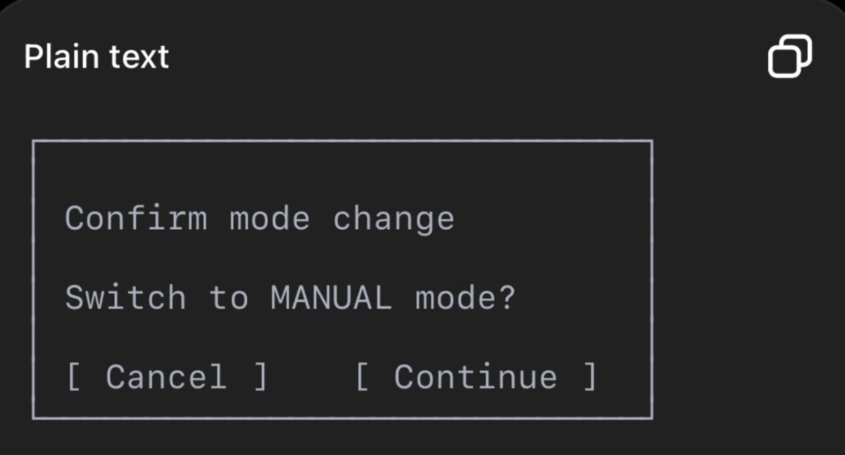Don’t use modals for every tiny action.

30. Spray Confirmation
For ASSISTED mode, confirmation is explicit.
For AUTO, no confirmation should interrupt every plant.
For MANUAL, pressing SPRAY should execute immediately within safety limits.
For Emergency Stop, no confirmation.

31. Loading States
Never leave the user staring at a frozen button.
Examples:
Connecting...
◌
AI processing...
◌
Moving nozzle...
◌
Spraying...
◌

32. Empty States
History with no data:
No spray events yet.

Start scanning to see your
activity here.
Don’t display a blank screen.

33. Error States
Example:
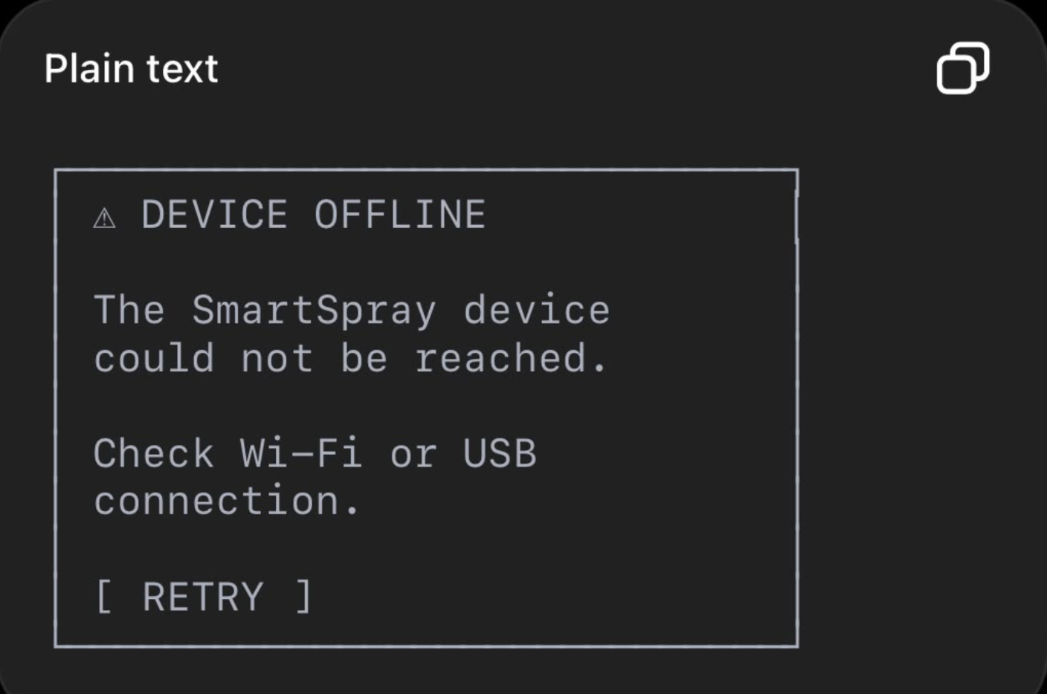

34. UX Error Copy
Use plain language.

Bad
ESP32_TIMEOUT

Good
Device didn’t respond.
Check the device connection.

Bad
AI_CONFIDENCE < THRESHOLD

Good
AI is uncertain.
Review the plant before spraying.

Bad
403 FORBIDDEN

Good
You don’t have permission to control this device.

35. Accessibility
Minimum requirements:
- 48×48 touch targets
- High contrast
- Don’t communicate status using color alone
- Text labels for icons
- Large emergency stop
- Readable typography
- Avoid tiny dashboard text

36. Flutter Architecture
Use feature-based architecture.
lib/
│
├── main.dart
│
├── app/
│ ├── app.dart
│ ├── router.dart
│ └── theme.dart
│
├── core/
│ ├── constants/
│ ├── errors/
│ ├── network/
│ ├── storage/
│ └── utils/
│
├── models/
│ ├── device.dart
│ ├── detection.dart
│ ├── spray_event.dart
│ ├── session.dart
│ └── statistics.dart
│
├── services/
│ ├── api_service.dart
│ ├── websocket_service.dart
│ └── device_service.dart
│
├── features/
│ │
│ ├── dashboard/
│ │ ├── dashboard_screen.dart
│ │ ├── dashboard_provider.dart
│ │ └── widgets/
│ │
│ ├── detection/
│ │ ├── detection_screen.dart
│ │ ├── detection_provider.dart
│ │ └── widgets/
│ │
│ ├── control/
│ │ ├── control_screen.dart
│ │ ├── control_provider.dart
│ │ └── widgets/
│ │
│ ├── history/
│ │ ├── history_screen.dart
│ │ └── history_provider.dart
│ │
│ └── settings/
│ ├── settings_screen.dart
│ └── settings_provider.dart
│
└── widgets/
├── status_card.dart
├── detection_card.dart
├── mode_selector.dart
├── primary_button.dart
├── emergency_stop.dart
└── loading_indicator.dart

37. State Management
I recommend:

Riverpod
Use it for:
- Device state
- Current mode
- Detection state
- WebSocket state
- Spray state
- User role
- History
Avoid putting API calls directly inside widgets.
Bad:
onPressed: () async {
// 100 lines of API logic
}
Better:
Widget
↓
Provider
↓
Service
↓
API

38. API Integration Architecture
The app communicates with one backend, not multiple third-party services.
Flutter
│
├── REST
│
└── WebSocket
│
▼
FastAPI

Important conclusion
There are currently no third-party SaaS APIs required by the mobile app.
You previously considered AWS, but the architecture deliberately removed it because the AI runs locally on the laptop.
So:
- No AWS API
- No Firebase requirement
- No Google Maps
- No external AI API
- No cloud database
- No authentication provider
This is good for V1.

39. Internal API Base URL
Development:
http://<LAPTOP-IP>:8000/api/v1
Example:
http://192.168.1.10:8000/api/v1
WebSocket:
ws://<LAPTOP-IP>:8000/ws
Do not hardcode the IP.
Store it in configuration.

40. API Authentication
For MVP device pairing:
Authorization: Bearer <device_session_token>
Flutter stores the token using secure platform storage.
Do not store it in ordinary plaintext preferences.

41. API Response Format
Use a consistent structure.

Success
{
"success": true,
"data": {
"device_id": "device-001",
"status": "online"
}
}

Error
{
"success": false,
"error": {
"code": "DEVICE_OFFLINE",
"message": "The device is currently offline."
},
"request_id": "req-123"
}

42. Device Status API

Request
GET /api/v1/devices/{deviceId}/status

Response
{
"device_id": "device-001",
"status": "online",
"mode": "assisted",
"ai_status": "ready",
"pump_status": "off",
"servo_angle": 87,
"last_seen": "2026-08-18T18:50:00+05:30"
}

43. Latest Detection API

Request
GET /api/v1/detections/latest

Response
{
"id": "det-123",
"plant_id": 17,
"disease": "Early Blight",
"confidence": 0.94,
"severity_percent": 42,
"spray_level": "medium",
"timestamp": "2026-08-18T18:51:03+05:30"
}

44. Mode API

Request
POST /api/v1/devices/{deviceId}/mode
Body:
{
"mode": "assisted"
}
Allowed:
auto
assisted
manual
Response:
{
"success": true,
"mode": "assisted"
}

45. Manual Spray API

Request
POST /api/v1/spray/manual
Body:
{
"device_id": "device-001",
"servo_angle": 90,
"duration_ms": 1000,
"command_id": "cmd-123"
}
Backend validates everything before sending to ESP32.
Response:
{
"spray_id": "spray-001",
"status": "started"
}

46. Stop API
POST /api/v1/spray/stop
Response:
{
"status": "stopped"
}
This should be designed as an idempotent operation.
Calling STOP twice should still leave the pump OFF.

47. Emergency Stop API
POST /api/v1/device/emergency-stop
Response:
{
"status": "emergency_stop_active"
}
The UI should immediately reflect:
🔴 EMERGENCY STOP ACTIVE

48. History API
GET /api/v1/spray/history
Optional:
?limit=20
&offset=0
Response:
{
"items": [
{
"id": "spray-001",
"disease": "Early Blight",
"severity": 42,
"spray_level": "medium",
"duration_ms": 1000,
"status": "completed",
"timestamp": "2026-08-18T18:40:00+05:30"
}
],
"total": 1
}

49. WebSocket Integration
Connection:
ws://192.168.1.10:8000/ws/device/device-001
Events:
{
"event": "DISEASE_DETECTED",
"data": {
"disease": "Early Blight",
"confidence": 0.94,
"severity": 42
}
}
Then:
{
"event": "SPRAY_STARTED",
"data": {
"servo_angle": 87,
"duration_ms": 1000
}
}
Then:
{
"event": "SPRAY_COMPLETED",
"data": {
"spray_id": "spray-001"
}
}
Flutter should update its state from these events.

50. WebSocket Failure
If WebSocket disconnects:
App:
🟡 Reconnecting...
Use exponential backoff.
For example:
1 sec
2 sec
4 sec
8 sec
maximum 30 sec
Do not continuously reconnect every few milliseconds.

51. Third-Party Service Specification
For V1, the answer is intentionally simple:
Service | Used? | Purpose
AWS | ❌ | Not needed
Firebase | ❌ | Not needed
Google Maps | ❌ | Not needed
Google/Firebase Auth | ❌ | Not needed
OpenAI API | ❌ | Not needed
Cloud AI API | ❌ | Not needed
Cloud database | ❌ | Not needed
FastAPI | ✅ | Internal backend
ESP32 | ✅ | Internal hardware
YOLO | ✅ | Local AI
OpenCV | ✅ | Local computer vision
FastAPI, YOLO and ESP32 are components of your own system, not third-party SaaS services.

52. Development Dependencies
These are libraries, not external services:

Flutter
flutter_riverpod
dio
web_socket_channel
go_router
shared_preferences
flutter_secure_storage
intl
fl_chart

Python
fastapi
uvicorn
pydantic
sqlalchemy
alembic
aiosqlite
pyserial
opencv-python
numpy
ultralytics
torch
The team should avoid adding packages unless there’s a clear reason.

53. Environment Configuration
Flutter should receive:
API_BASE_URL
WS_BASE_URL
Example:
API_BASE_URL=http://192.168.1.10:8000/api/v1
WS_BASE_URL=ws://192.168.1.10:8000/ws
Backend:
APP_HOST=0.0.0.0
APP_PORT=8000

DATABASE_URL=sqlite:///./data/smartspray.db

AI_MODEL_PATH=./data/models/best.pt

AI_CONFIDENCE_THRESHOLD=0.50

MAX_SERVO_ANGLE=160
MIN_SERVO_ANGLE=20

MAX_PUMP_DURATION_MS=3000

54. Responsive Design
The initial target is Android phones.
Design around:
360–430 px width
The app should still work on larger phones.
Don’t design exclusively around one specific phone.
Use Flutter’s responsive layout rather than fixed pixel positioning.

55. Portrait vs Landscape

Default
Portrait
Better for handheld operation.

Detection
Optional landscape mode if you eventually show a large live camera feed.
But don’t make landscape a V1 requirement.

56. Demo Mode
I strongly recommend adding a hidden/developer Demo Mode.
It should simulate:
Plant detected
↓
Disease detected
↓
Severity 62%
↓
Spray recommendation
↓
ESP32 command
Why?
If your camera suddenly fails during the hackathon, you can still demonstrate the UI.
But be honest:
“Demo mode is being used.”
Do not fake successful real-world spraying and present it as real.

57. Frontend Definition of Done
The Flutter frontend is ready for MVP when:
- App launches without errors
- Device connection is visible
- Dashboard works
- AUTO/ASSISTED/MANUAL switching works
- AI detection appears in the app
- Severity appears correctly
- Assisted SPRAY button works
- Manual servo control works
- Manual pump control works
- STOP works
- Emergency STOP is clearly visible during spraying
- History displays completed events
- Offline state is handled
- WebSocket reconnect works
- Unauthorized actions are rejected
- No API credentials are hardcoded
- UI doesn’t freeze while AI is processing

58. Final UI Architecture
The final application should feel like this:
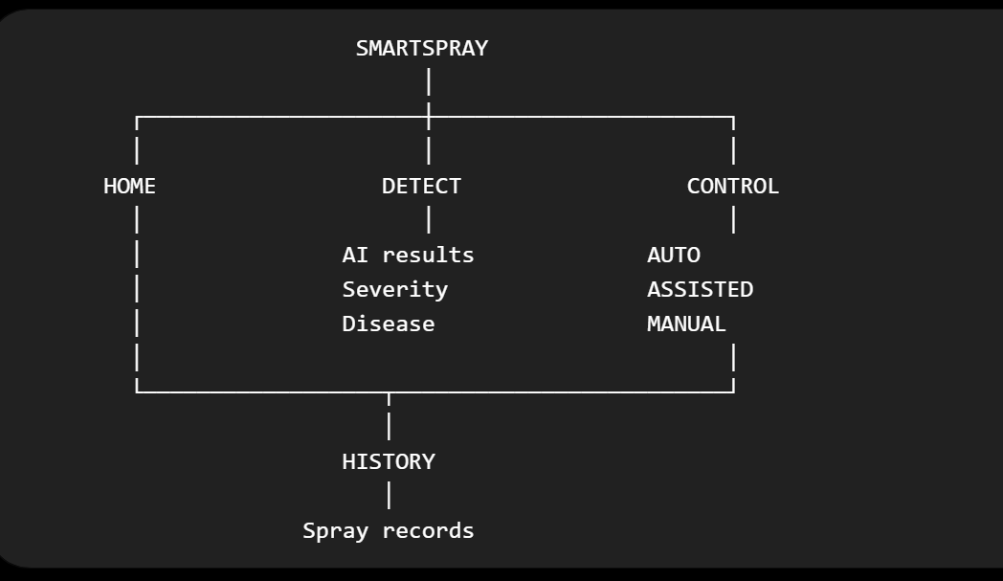And during a real operation:
📷 PLANT
↓
💻 AI DETECTION
↓
Disease: Blight
Severity: 62%
↓
📱 ASSISTED MODE
↓
[ SPRAY ] [ SKIP ]
↓
ESP32
↓
Servo → Nozzle
↓
Pump
↓
🌱 Spray
↓
✅ COMPLETED
↓
HISTORY

Final recommendation
For V1, do not build a giant agricultural dashboard.
Build a small, extremely polished control application around the one impressive interaction:
AI detects a diseased plant → phone shows the result → farmer approves/automation triggers → nozzle moves → pump sprays → result is recorded.
That interaction should dominate the UI.
Everything else—statistics, settings, charts, elaborate profiles, cloud services—should stay secondary until that core loop is reliable.

